LAB211 Assignment | Type: | Short Assignment
 | Code: | J1.S.P0075
 | LOC: | 100
 | Slot(s): | 2

Title
Handle file program (extraction from CBDT project)
Background
NA
Program Specifications
Develop a file processing program include functions:
- .Enter the path and then check it is exist or not? If path exist, that is file path or directory path?
- Enter a directory path and then list all file with .java extension.
- Enter a directory path and an integer n(KB). Find all the files with size > n in the directory and print to the screen.
- Enter file path then insert more content from the keyboard.
- Enter a file txt path Count the number of word in the file (each word is separated by a whitespace)
Function details:
Function 1: Display a menu and ask users to select an option.
- Users run the program. The program prompts users to select an option.
- Users select an option, perform Function 2.
Function 2: Perform function based on the selected option..
- Option 1: Check the path
- Enter a path and check the path is exits or not ?
- If not, display a notice : “Path doesn’t exist”
- . If path exist, display a notice that is file path or directory path?

- Option 2: Listed file .java
- Enter a path and check the path is exits
- If not, display a notice : “Path doesn’t exist”
- Display quantity of .java file
- Option 3: List all files with file size larger than input size
- Enter size n(KB) , Check n must be numeric , if it is the other type then display notice: “Value of size is digit”
- Enter a path
- If not exist display a notice : “Path doesn’t exist”, Please Try again.
- Display quantities of file and print file name with size > n in the folder.
- Option 4: Enter file path then add more content from the keyboard.
- Input content from keyboard that the user want to add to file
- Enter file path
- If not exist display a notice: “Path doesn’t exist” Please Try again.
- Notice that successfully add content inputted from keyboard into file
- Option 5: Count word in .text file
- Enter a path to.txt file
- Print to screen total word of file
- Option 6: Exit program

Expectation of User interface:
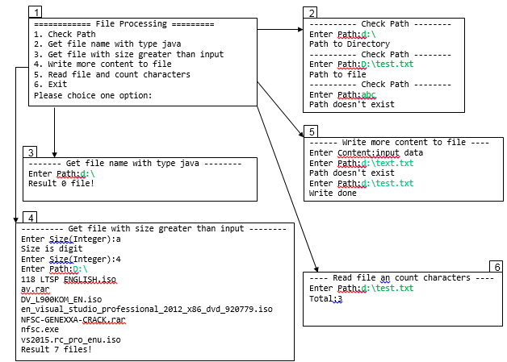

Guidelines

Student must implement methods
checkInputPath
getAllFileNameJavaInDirectory
getFileWithSizeGreaterThanInput
appendContentToFile
countCharacter
in startup code.

Use the classes:
java.io.BufferedReade,java.io.BufferedWriter,java.io.File, java.io.FileFilter, java.io.FileReader, java.io.FileWriter, java.io.FilenameFilter, java.io.IOException, java.util.ArrayList, java.util.List;
to file manipulation.
Function 1: Check the path
- Implement function: public void checkInputPath(String path) throws Exception
  - Input:
- path: File path or Directory path
  - Return value:
- Exception("Path doesn't exist").
- Exception("Path to file").
- Exception("Path to Directory").
Function 2: List all the java file .
- Implement function: List<String> getAllFileNameJavaInDirectory(String path) throws Exception
  - Input:
- path: File path
  - Return value:
- List of file name.
- Exception("Path doesn't exist").
function 3: Search file with file size lager than n
- Implement function: public static File[] getFileWithSizeGreaterThanInput(String path, int size) throws Exception.
  - Input:
- path: File path
- size: file size
  - Return value:
- List of file.
- Exception("Path doesn't exist").
function 4: Add content from keyboard.
- Implement function: public boolean appendContentToFile(String path, String contentInput) throws Exception.
  - Input:
- path:File path
- contentInput: inputted content from keyboard
  - Return value:
- Recording status file.
- Exception("Path doesn't exist").
function 5: Count the number of character which are separated by a whitespace in file.
- Implement function: public int countCharacter(String path) throws Exception.
  - Input:
- path: file path
  - Return value:
- Number of character.
- Exception("Path doesn't exist").

